# Program no. 1:- jspDemo1

Practical no. 6

**AIM :** Write a jsp program to demonstrate directives declaration on jsp page. Index.jsp

<!DOCTYPE html>

<html>

<head>

<meta http-equiv=*"content-Tyoe"* content=*"text/html; charset=UTF-8"*>

<title>Page Attribute </title>

</head>

<body>

<form action=*"directive.jsp"*>

<h1> Enter the value of n1 and n2: </h1>

Number1: <input type=*"number"* name=*"n1"*/><br/> Number2: <input type=*"number"* name=*"n2"*/><br/>

<input type=*"submit"*/>

</form>

</body>

</html>

# error.jsp

<%@ page contentType=*"text/html"* pageEncoding=*"UTF-8"*%>

<%@ page isErrorPage=*"true"* %>

<!DOCTYPE html>

<html>

<head>

<meta http-equiv=*"content-Type"* content=*"text/html; charset=UTF-8"*>

<title>Page Attributes</title>

</head>

<body>

<h2> Value of n2 variable of zero(n/0 is infinity)</h2>

<h3> Sorry an exception occurred!</h3> <br/>

<h3> The Exception is: <%= exception %></h3>

</body>

</html>

# directive.jsp

<%@ page contentType=*"text/html"* pageEncoding=*"UTF-8"*%>

<%@ page import=*"java.util.*"* %>

<%@ page info=*"composed by DSATM"* %>

<%@ page language=*"java"* %>

<%@ page buffer=*"16kb"* %>

<%@ page autoFlush=*"true"* %>

<%@ page isThreadSafe=*"true"* %>

<%@ page errorPage=*"error.jsp"* %>

<!DOCTYPE html>

<html>

<head>

<meta http-equiv=*"content-Type"* content=*"text/html; charset=UTF-8"*>

<title>Page Attributes</title>

</head>

<body bgcolor=*"orange"*>

<h2> Usage of import attributes</h2>

<h2> Todays Date is: <%=**new** Date() %></h2>

<h2> To see the use of error page enter n2 value zero and click submit</h2>

<%

**int** n1=Integer.parseInt(request.getParameter("n1")); **int**

n2=Integer.parseInt(request.getParameter("n2"));

%>

<h2> Value of n1/n2 :<%=n1/n2 %></h2>

</body>

</html>

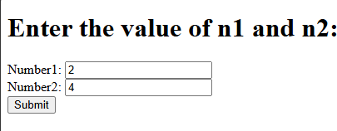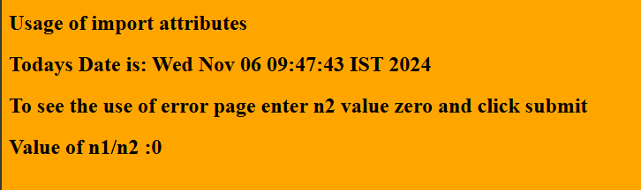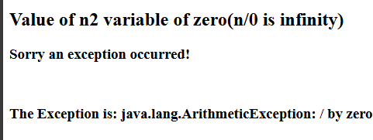

**Program no. 2:- jspDemo2**

**Aim: Write a JSP program that demonstrates the use of JSP declaration, scriptlet, directives, expression,header and footer.**

**Sonia.jsp**

<%@ page language=*"java"* contentType=*"text/html; charset=ISO-8859-1"* pageEncoding=*"ISO-8859-1"*

%>

<%@ include file=*"header.html"* %>

<!DOCTYPE html>

<html>

<head>

<meta charset=*"ISO-8859-1"*>

<title>JSP Demo Page</title>

</head>

<body>

<h1>Enter the Message</h1>

<form action=*"Response.jsp"* method=*"post"*>

Enter Message: <input type=*"text"* value=*""* name=*"text1"*>

<input type=*"submit"* value=*"Submit"* />

</form>

</body>

</html>

<%@ include file=*"footer.html"* %>

# Response.jsp

<%@ page language=*"java"* contentType=*"text/html; charset=ISO-8859-1"* pageEncoding=*"ISO-8859- 1"*%> <%@ include file=*"header.html"* %>

<!DOCTYPE html>

<html>

<head>

<meta charset=*"ISO-8859-1"*>

<title>Insert title here</title>

</head>

<body>

<% String s1=request.getParameter("text1"); %>

<%=s1%>

</body>

</html>

<%@include file=*"footer.html"* %>

# header.html

<!DOCTYPE html>

<html>

<head>

<meta charset="ISO-8859-1">

<title>Insert title here</title>

</head>

<body>

<h1> hello welcome back to jsp</h1>

</body>

</html>

# footer.html

<!DOCTYPE html>

<html>

<head>

<meta charset="ISO-8859-1">

<title>Insert title here</title>

</head>

<body>

<h3>visit again</h3>

</body>

</html>

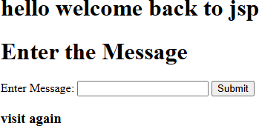

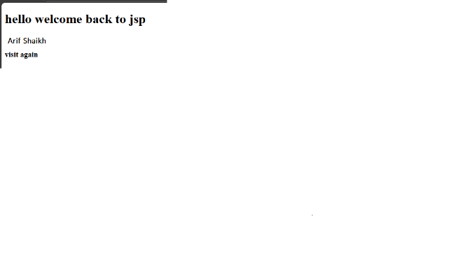

# Program no. 3 calculator

**AIM: -** Design Grade calculator using JSP which accepts Marks of subjects. Calculate average of marks and Display the grade of student based on average marks**.**

<%@ page language=*"java"* contentType=*"text/html; charset=ISO-8859-1"* pageEncoding=*"ISO-8859- 1"*%>

<!DOCTYPE html>

<html>

<head>

<meta charset=*"ISO-8859-1"*>

<title>Insert title here</title>

</head>

<body>

<h2>Grade Calculator Main content of the page</h2>

<form action=*""* method=*"post"*>

<table>

<tr><td>Program: MCA</td>

<td></td></tr>

<tr><td>JAVA (out of 100):</td>

<td><input type=*"text"* value=*""* name=*"text1"*></td></tr>

<tr><td>ADBMS (out of 100):</td>

<td><input type=*"text"* value=*""* name=*"text2"*></td></tr>

<tr><td>SPM (out of 100):</td>

<td><input type=*"text"* value=*""* name=*"text3"*></td></tr>

<tr><td>MATHS (out of 100):</td>

<td><input type=*"text"* value=*""* name=*"text4"*></td></tr>

<tr><td></td>

<td><input type=*"submit"* value=*"Submit"* name=*"Submit"* /></td></tr>

<tr>

</table>

</form>

<% **try** {

String res="";

**int** t1=Integer.parseInt(request.getParameter("text1")); **int** t2=Integer.parseInt(request.getParameter("text2")); **int** t3=Integer.parseInt(request.getParameter("text3")); **int** t4=Integer.parseInt(request.getParameter("text4"));

**float** r, av; r=t1+t2+t3+t4; av=r/4; **if**(av>75 && av<=100){ res="You have passed with O Grade."; }

**else if**(av>60 && av<=75){ res="You have passed with A Grade."; }

**else if**(av>50 && av<=60){ res="You have passed with B Grade."; }

**else if**(av>40 && av<=50){ res="You have passed with C Grade."; }

# else{

res="You have Failed."; }

%>

<%= av%>

<br>

<%= res %>

<% } **catch**(Exception e) { } %>

</body>

</html>

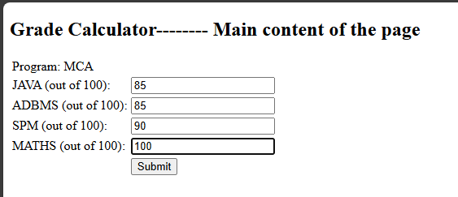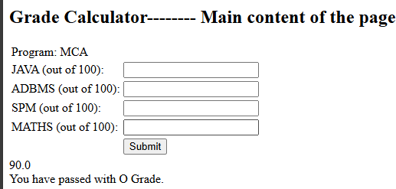

# Program no. 4 Session

**AIM**: Write a program in JSP to demonstrate session tracking technique.

Session.jsp

<%@ page language=*"java"* contentType=*"text/html; charset=ISO-8859-1"*

pageEncoding=*"ISO-8859-1"*%>

<!DOCTYPE html>

<html>

<head>

<meta charset=*"ISO-8859-1"*>

<title>Insert title here</title>

</head>

<%@ page import = *"java.io.*,java.util.*"* %>

<% // Get session creation time.

Date createTime = **new** Date(session.getCreationTime()); // Get last access time of this Webpage.

Date lastAccessTime = **new** Date(session.getLastAccessedTime()); String title = "Welcome Back to my website";

Integer visitCount = **new** Integer(0);

String visitCountKey = **new** String("visitCount"); String userIDKey = **new** String("userID");

String userID = **new** String("ABCD");

// Check if this is new comer on your Webpage

**if** (session.isNew() ){ title = "Welcome to my website"; session.setAttribute(userIDKey, userID); session.setAttribute(visitCountKey, visitCount);

}

visitCount = (Integer)session.getAttribute(visitCountKey); visitCount = visitCount + 1;

userID = (String)session.getAttribute(userIDKey); session.setAttribute(visitCountKey, visitCount);

%>

<body>

<center>

<h1>Session Tracking</h1>

</center>

<table border = *"1"* align = *"center"*>

<tr bgcolor = *"#949494"*>

<th>Session info</th>

<th>Value</th>

</tr>

<tr>

<td>id</td>

<td><% out.print( session.getId()); %></td>

</tr>

<tr>

<td>Creation Time</td>

<td><% out.print(createTime); %></td>

</tr>

<tr>

<td>Time of Last Access</td>

<td><% out.print(lastAccessTime); %></td>

</tr>

<tr>

<td>User ID</td>

<td><% out.print(userID); %></td>

</tr>

<tr>

<td>Number of visits</td>

<td><% out.print(visitCount); %></td>

</tr>

</table>

</body>

</html>

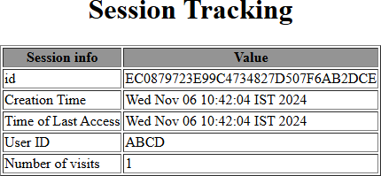

# Program no. 5 Student Record

**AIM : WAP to Insert records in Student Master.** **PgADMIN**

CREATE TABLE student( sname varchar(10), srollno varchar(50), scoll varchar (50), sadd varchar(50)

);

select * from student;

# student.jsp

<%@ page language=*"java"* contentType=*"text/html; charset=ISO-8859-1"*

pageEncoding=*"ISO-8859-1"*%>

<!DOCTYPE html>

<html>

<head>

<meta charset=*"ISO-8859-1"*>

<title>Insert title here</title>

</head>

<body>

<h1>student master</h1>

<form action=*"response.jsp"* method=*"post"*>

<table>

<tr><td>Student Name :</td>

<td><input type=*"text"* name=*"text1"* /></td></tr>

<tr><td>Roll No : </td>

<td><input type=*"text"* name=*"text2"* /></td></tr>

<tr><td>Name of the College:</td>

<td><input type=*"text"* name=*"text3"* /></td></tr>

<tr><td>Address :</td>

<td><input type=*"text"* name=*"text4"* /></td></tr>

</table>

<input type=*"submit"* value=*"Submit"* />

</form>

</body>

</html>

# response.jsp

<%@ page language=*"java"* contentType=*"text/html; charset=ISO-8859-1"*

pageEncoding=*"ISO-8859-1"*%>

<!DOCTYPE html>

<html> <head>

<meta charset=*"ISO-8859-1"*>

<title>Insert title here</title>

</head> <body>

<%@page import=*"java.sql.*"* %>

<% **try** { Class.forName("org.postgresql.Driver"); System.out.println("Drivers Registered"); Connection con=DriverManager.getConnection(

"jdbc:postgresql://localhost:5432/postgres","postgres","abc"); String t1, t2, t3, t4; t1=request.getParameter("text1"); t2=request.getParameter("text2"); t3=request.getParameter("text3"); t4=request.getParameter("text4");

PreparedStatement ps;

ps=con.prepareStatement("insert into student(sname,srollno,scoll,sadd) values(?,

?, ?, ?);"); ps.setString(1, t1); ps.setString(2, t2); ps.setString(3, t3); ps.setString(4, t4); ps.executeUpdate(); out.println("Record inserted successfully."); Statement st=con.createStatement();

String sql="select * from student";

ResultSet rs=st.executeQuery(sql); **while**(rs.next())

{

String n1=rs.getString(1); String n2=rs.getString(2); String n3=rs.getString(3); String n4=rs.getString(4);

%> <br>

<% out.println(n1+" "+n2+" "+n3+" "+n4);}

} **catch**(Exception e){ out.println(e); } %>

</body>

</html>

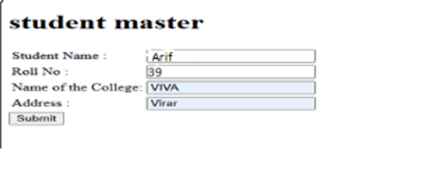

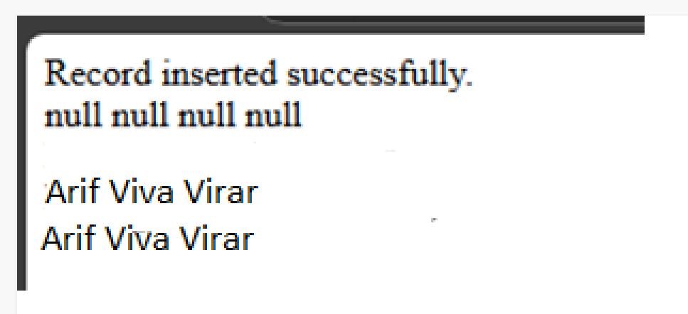

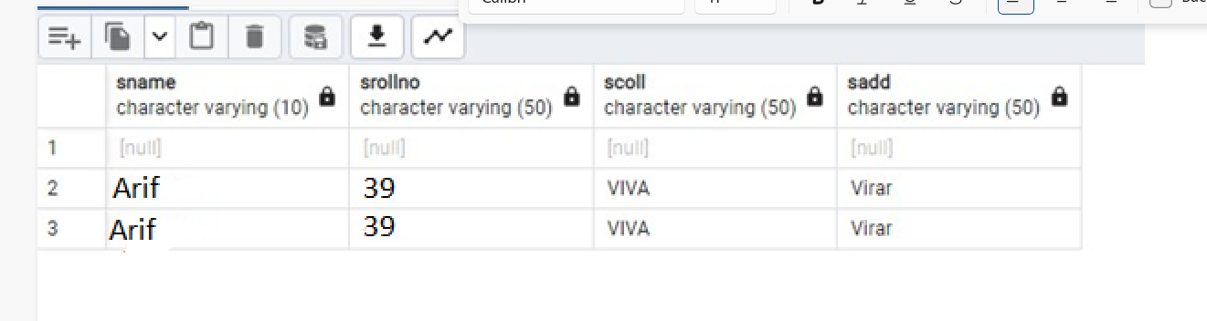

# Program no. 6 Delete Student Record AIM WAP to Delete records in Student Master.

**delete.jsp**

<%@ page language=*"java"* contentType=*"text/html; charset=ISO-8859-1"*

pageEncoding=*"ISO-8859-1"*%>

<!DOCTYPE html>

<html> <head>

<meta charset=*"ISO-8859-1"*>

<title>Insert title here</title>

</head> <body>

<h1>student master</h1>

<form action=*"response1.jsp"* method=*"post"*>

<table> <tr><td>Student Name :</td>

<td><input type=*"text"* name=*"text1"* /></td></tr>

<tr><td>Roll No : </td>

<td><input type=*"text"* name=*"text2"* /></td></tr>

<tr><td>Name of the College:</td>

<td><input type=*"text"* name=*"text3"* /></td></tr>

<tr><td>Address :</td>

<td><input type=*"text"* name=*"text4"* /></td></tr>

</table>

<input type=*"submit"* value=*"Submit"* />

</form> </body> </html>

# response1.jsp

<%@ page language=*"java"* contentType=*"text/html; charset=ISO-8859-1"*

pageEncoding=*"ISO-8859-1"*%>

<!DOCTYPE html>

<html> <head>

<meta charset=*"ISO-8859-1"*>

<title>Insert title here</title>

</head> <body>

<%@page import=*"java.sql.*"* %>

<% **try** { Class.forName("org.postgresql.Driver"); System.out.println("Drivers Registered"); Connection con=DriverManager.getConnection(

"jdbc:postgresql://localhost:5432/postgres","postgres",""); String t1, t2, t3, t4; t1=request.getParameter("text1");

t2=request.getParameter("text2"); t3=request.getParameter("text3");

t4=request.getParameter("text4");

PreparedStatement ps;

//insert into student(sname,srollno,scoll,sadd) values(?, ?, ?, ?); ps=con.prepareStatement("DELETE FROM student where srollno= ?;"); ps.setString(1, t2); /*ps.setString(1, t1); ps.setString(3, t3); ps.setString(4, t4);*/ ps.executeUpdate();

//out.println("Record inserted successfully."); Statement st=con.createStatement();

String sql="select * from student";

ResultSet rs=st.executeQuery(sql); **while**(rs.next())

{ String n1=rs.getString(1); String n2=rs.getString(2); String n3=rs.getString(3); String n4=rs.getString(4);

%> <br>

<% out.println(n1+" "+n2+" "+n3+" "+n4 ); }

} **catch**(Exception e){ out.println(e); } %>

</body> </html>

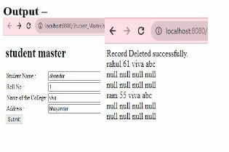

# Program no. 7 Registration form

**AIM Write a program to create registration form[JSP to Database** pgADMIN CREATE TABLE

register( uid varchar(20), pass varchar(10), fname varchar(50), lname varchar (50),

email varchar(50)

);

Select * from register

# register.jsp

<%@ page language=*"java"* contentType=*"text/html; charset=ISO-8859-1"*

pageEncoding=*"ISO-8859-1"*%>

<!DOCTYPE html>

<html> <head>

<meta charset=*"ISO-8859-1"*>

<title>Insert title here</title>

</head> <body>

<h1>Registration Form</h1>

<form action=*"response.jsp"* method=*"post"*>

<table> <tr><td>UserID:</td>

<td><input type=*"text"* name=*"text1"* /></td></tr>

<tr><td>Password:</td>

<td><input type=*"password"* name=*"text2"* /></td></tr>

<tr><td>First Name:</td>

<td><input type=*"text"* name=*"text3"* /></td></tr>

<tr><td>Last Name:</td>

<td><input type=*"text"* name=*"text4"* /></td></tr>

<tr><td>Email-id:</td>

<td><input type=*"email"* name=*"text5"* /></td></tr>

</table>

<input type=*"submit"* value=*"Submit"* />

</form> </body> </html>

# response.jsp

<%@ page language=*"java"* contentType=*"text/html; charset=ISO-8859-1"*

pageEncoding=*"ISO-8859-1"*%>

<!DOCTYPE html>

<html> <head>

<meta charset=*"ISO-8859-1"*>

<title>Insert title here</title>

</head> <body>

<%@page import=*"java.sql.*"* %>

<% **try** { Class.forName("org.postgresql.Driver"); System.out.println("Registered");

Connection con=DriverManager.getConnection( "jdbc:postgresql://localhost:5432/postgres","postgres","abc"); String t1, t2, t3, t4, t5; t1=request.getParameter("text1"); t2=request.getParameter("text2"); t3=request.getParameter("text3"); t4=request.getParameter("text4"); t5=request.getParameter("text5");

PreparedStatement ps;

ps=con.prepareStatement("insert into register(uid, pass, fname, lname, email) values(?, ?, ?, ?, ?);");

ps.setString(1, t1);

ps.setString(2, t2); ps.setString(3, t3); ps.setString(4, t4); ps.setString(5, t5); ps.executeUpdate();

out.println("Record inserted successfully."); Statement st=con.createStatement();

String sql="select * from register"; ResultSet rs=st.executeQuery(sql); **while**(rs.next()) { String n1=rs.getString(1);

String n2=rs.getString(2); String n3=rs.getString(3); String n4=rs.getString(4); String n5=rs.getString(5);

%>

<br>

<% out.println(n1+" "+n2+" "+n3+" "+n4 ); }

} **catch**(Exception e){ out.println(e); } %>

</body> </html>

